|  |
| --- |
| http://www.aquacave.com/media/catalog/product/cache/1/image/700x/8f39017fa9e41584ae4b73c321149768/9/0/9000phcombo-700.jpg**Buffer Solutions**  **What is a Buffer Solution?**  **Buffer** means to **“**lessen or moderate the impact of something”.  In Chemistry, a buffer solution is one that resists changes in pH when small quantities of an acid or base are added to it.  A buffer is a weak conjugate acid-base pair:   * Weak acid and its conjugate base * Weak base and its conjugate acid   Image result for nerd  The word “conjugate” comes from the Latin word *conjugātus*, joined together in a pair”  **Types of Buffer Solutions**  **Acidic buffer solutions**  An acidic buffer solution is simply one that has a pH less than 7. Acidic buffer solutions are commonly made from a weak acid and one of its salts - often a sodium salt. A common example would be a mixture of ethanoic acid and sodium ethanoate in solution.  In a buffer solution, the acid / conjugate base concentrations are usually made the same. |
| **Alkaline buffer solutions**  An alkaline buffer solution has a pH greater than 7. Alkaline buffer solutions are commonly made from a weak base and one of its salts. A frequently used example is a mixture of ammonia solution and ammonium chloride solution.  Again, the base / conjugate acid concentrations are usually made the same.  **How do buffer solutions work?**  A buffer solution contains a species that removes any hydronium ions or hydroxide ions that you add. This prevents any major pH change. Since acidic buffers are more common, we will look at them. The way in which basic buffers function is similar. |

***Adding an acid to an ethanoic acidic buffer solution***

Adding the acid Increases the hydronium ion concentration [H3O+] shifting the equilibrium to the left. This results in hydronium ions combining with the ethanoate ions to make ethanoic acid molecules, removing **most** of the added hydronium ions from the solution.



Since most of the added hydronium ions are removed, the pH will not change very much.

***Adding an base to an ethanoic acidic buffer solution***

The added [OH-] ions can be removed by two methods.

Since ethanoic acid is a weak acid, there are many more molecules of ethanoic acid than there are hydronium ions. Both of these species can potential act as an acid and react with the OH- ions.

When the base is added, the OH- ions are more likely to hit the ethanoic acid molecules than the hydronium ions, since the ethanoic acid molecules are more numerous. This results in the ethanoic acid molecules donating a proton (acting as an acid) and the following reaction occurs.

This removes the added OH- ions and thus prevents the increase in pH.

A much smaller proportion of OH- ions would be removed by the reaction of the H3O+ ions with the OH- ions to form water. In this case, the hydronium ions donate the proton (act as an acid).

**H3O+(aq) + OH-(aq) ⇋ H2O(l)**

**Acid buffer System Summary**

In the ethanoic acid buffer system;

* the CH3COOH(aq), is the main reactant when base is added, removing the added OH- ions
* the CH3COO-(aq), reacts with any added acid, removing most of the added H3O+ ions

This can be generalised as follows:

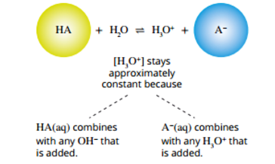

**Were:**

**HA is the acid**

**A- is the conjugate base**

**Other weak acid buffer examples**

carbonic acid H2CO3(aq) + H2O(l) ⇋ HCO3-(aq) + H3O+(aq)

dihydrogen phosphate H2PO4-(aq) + H2O(l) ⇋ HPO42-(aq) + H3O+(aq)

NB: Both of these buffering systems are important in human blood

**Buffer Capacity**

The goal of a buffer is to keep the pH of a solution within a narrow pH range. Buffer capacity is a measure of the efficiency of a buffer in resisting changes in ph.

The buffer capacity is higher if:

* the concentrations of the conjugate acid / base pair substances are high. A buffer is more effective with more HA and A-
* The concentrations of HA and A- are equal

The graph below compares adding hydrochloric acid to pure water or an ethanoic acid buffer solution [the 1 mol L-1 ethanoic acid buffer solution has a pH of approximately 4.7].

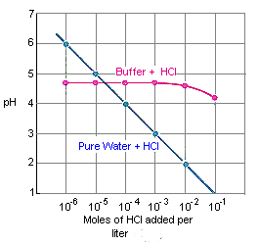

This graph shows the following:

* Adding HCl to pure water results in a consistent drop in pH [due to a build-up of hydronium ions].
* Adding HCl to the buffer solution initially results in very little change in the pH [most of the hydronium ions are removed].
* When the amount of acid added exceeds 10-3 moles per litre the pH starts to drop [The buffering capacity is exceeded and hydronium ions start to build up].

**Biological Buffers**

Buffers are essential to life. They help maintain the proper functioning of cellular systems by resisting rapid changes in pH.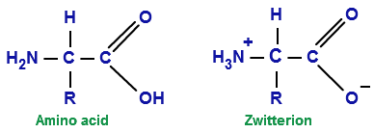

Amino acids when dissolved in water are present in zwitterion form. These molecules have the ability to react with small amounts of added acid (H+) or base (OH-) and therefore have the ability to resist pH change, acting as natural buffers.

**Adding acid (H+) to a zwitterion**

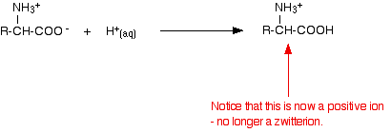

zwitterion

**Adding base (OH-) to a zwitterion**

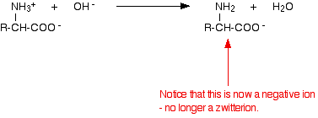

zwitterion